Housing Options:
Front:
Home:  Bedroom in a shared house  Rent: $450/month  Pros: Inexpensive  Cons: Must share common space with three other people  Pay to: Friendly Living Company | 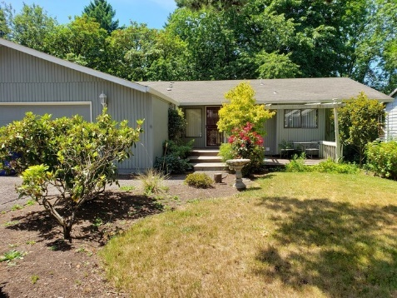

Back:
Home | Take 5 points
Bedroom in shared house

Front:
Home  Shared two-bedroom apartment  Rent: $700/month  Pros: Less expensive than living alone  Cons: Must share common space with another person  Pay to: Standard Property Company | 
Back:
Home | Take 4 points
Shared two-bedroom apartment

Front:
Home  Studio apartment  Rent: $850/month  Pros: Close to downtown and work, walkable  Cons: More expensive, not a lot of space  Pay to: Dollhouse properties | 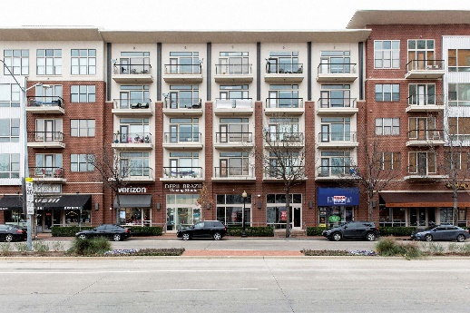

Back:
Home | Take 3 points
Studio apartment

Front:
Home  One-bedroom apartment  Rent: $1100/month  Pros: More personal space  Cons: More expensive  Pay to: American Property Management | 

Back:
Home | Take 2 points
One bedroom apartment

Front:
Home  Small home  Mortgage: $1150/month  Pros: Over time, you will own the home  Cons: Needs some repairs and updates; put all savings into down payment  Pay to: Happy Homes Mortgage Company | 

Back:
Home | Take 1 point
Small home

Front:
Home  Large suburban home  Mortgage: $1800/month  Pros: Plenty of living space  Cons: Long commute to work; put all savings into down payment  Pay to: Megabank Home Loans | 

Back:
Home | Take 0 points
Large suburban home
Transportation Options:
Front:
Transportation  Bus pass  $95/month  Pros: Inexpensive; better for the environment  Cons: Commute takes longer; limits where you can go  Pay to: City Transportation | 

Back:
Transportation | Take 5 points
Bus pass

Front:
Transportation  Basic used car  $1,800 one-time payment  Pros: Inexpensive  Con: Needs repairs and maintenance  Pay to: Happy Auto | 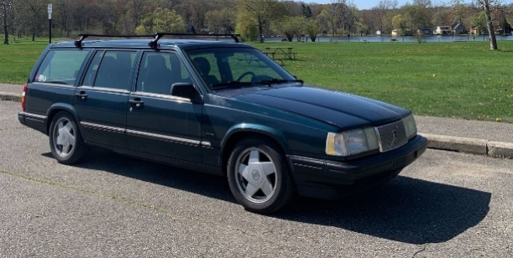

Back:
Transportation | Take 3 points
Basic used car
Front:
Transportation  Basic new car  $280/month five-year loan  Pros: Reliable transportation  Cons: More expensive, regular payments you need to make each month  Pay to: Sam’s New Cars | 

Back:
Transportation | Take 1 point
Basic used car

Front:
Transportation  Leased luxury car  $650/month three-year lease  Pros: Luxurious car you’ve always dreamed of  Cons: Very expensive; long-term loan  Pay to: Fast & Fun Auto | 

Back:
Transportation | Take no points
Leased luxury car
Wellness Options:
Front:
Wellness  Community Fair Outing  $20 entrance fee  Pros: Inexpensive  Cons: Crowded with long lines  Pay to: Community Events | 

Back:
Wellness | Take 4 points
Community Fair Outing

Front:
Wellness  Day at the Spa  $125  Pros: Relaxing and rejuvenating; self-care  Cons: Expensive for one day  Pay to: Dreamscape Spa | 

Back:
Wellness | Take 3 points
Day at the Spa
Front:
Wellness  Adopt a dog  $400 adoption fee  Pros: Provides unconditional love and companionship  Cons: Ongoing cost for food and care  Pay to: County Animal Shelter | 

Back:
Wellness | Take 2 points
Adopt a Dog

Front:
Wellness  New Gaming Station & Games  $460  Pros: Provides at-home entertainment  Cons: Initial cost is expensive  Pay to: Super Electronics | 

Back:
Wellness | Take 2 points
New Gaming Station & Games

Front:
Wellness  60’ High Definition Television  $800  Pros: Provides at-home entertainment  Cons: Initial cost is quite expensive  Pay to: E-Mart | 

Back:
Wellness | Take 1 point
HD Television

Front:
Wellness  One Week All-Inclusive Resort Vacation  $1600  Pros: Very luxurious and relaxing vacation  Cons: Very expensive  Pay to: Serene Vacations | 

Back:
Wellness | Take 0 points
One Week All-Inclusive Resort Vacation

